Why is it important to identify & treat an infection early?
Infections in people with long term conditions are very common and can have a major effect on health and independence.
There can be an increased risk of infection in the elderly and in people with a compromised immune system. The most common infections are urine and chest infections. Classic symptoms like fever and cough are less commonly found in the elderly, who often have symptoms like weakness, confusion, or delirium. Furthermore, loss of appetite, functional decline, falls, weight loss or a slight increase in respiratory rate may be the only signs indicating an infection in older patients.
If identified early enough, infections can often be simply treated without the need for hospital admission and can avoid problems such as:
- Increased confusion
- Changes in behaviour/increase in agitation
- Increased risk of falls
- Increased disability and dependency
- Family distress
- Changes in care provision & medication
What are some of the symptoms of an infection?
- Feeling dizzy or faint
- drowsiness
- diarrhoea
- slurred speech
- muscle pains
- breathlessness
- less urine production than normal – for example, not urinating for a day
- cold, clammy and pale or mottled skin
- Raised temperature
- Altered behaviour/altered mental state, confusion, agitation, restlessness, hallucinations
- Deterioration of functional ability
- Feeling achy/tired, shivering/chills
- Falls/loss of balance
- Loss of appetite, feeling nauseous, being sick
- Chest infections - cough, shortness of breath , increased effort needed to breathe
- Urine infections: needing to go to the toilet more than usual, pain when passing water and feeling like you haven’t emptied your bladder, pain low down in the tummy, in your sides or your back, blood in the urine (any blood in the urine should always be checked out by the GP)
- Skin infection – redness, swelling or discharge at wound site, breakdown of a wound or a rash
If symptoms are present it’s time to speak to your GP surgery. If an infection is untreated, it may develop into sepsis, a life-threatening condition. You are more at risk of getting an infection if you have a weakened immune system, e.g. other long term medical conditions such as diabetes, COPD , asthma, heart disease , or if you are having chemotherapy, or if you have a catheter.
As a carer, you are often the “expert” in your loved one’s condition, and, as such, you’re ideally placed to know what is “normal” for the person and to be able to detect subtle changes. This can help to prevent avoidable life-changing illness or hospital admission, which can sometimes put you at higher risk of picking up infection. The same can be said for your own health – as a carer you can be aware of your own health changing and be alert for signs of infection in yourself

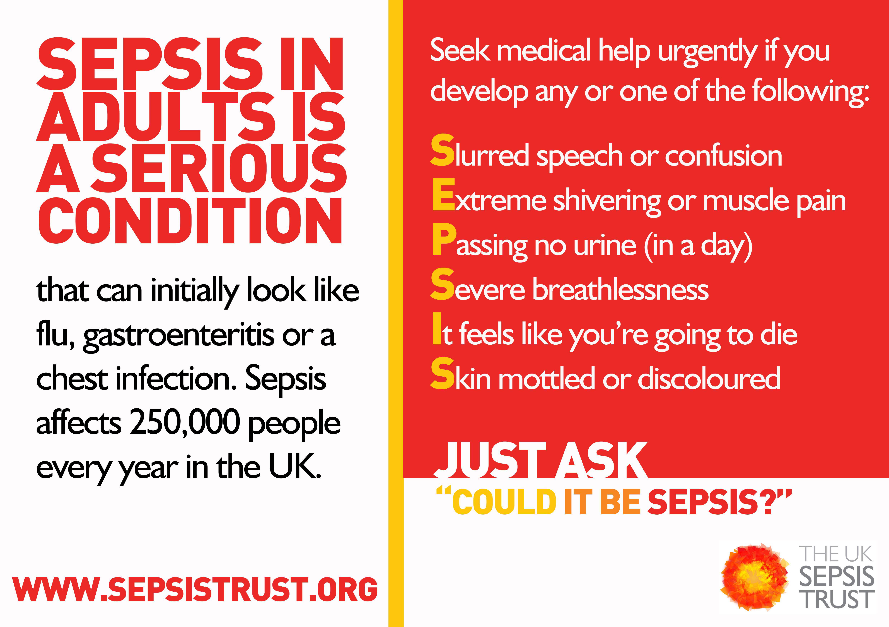

Image reproduced with kind permission of The UK Sepsis Trust

